|  |  |
| --- | --- |
| \\Usarisfile21\users\NWilliams\Documents\Pictures\District-of-RI copy.png | **United Against Hate Workshop**  **Identifying, Reporting, and Preventing Acts of Hate** |

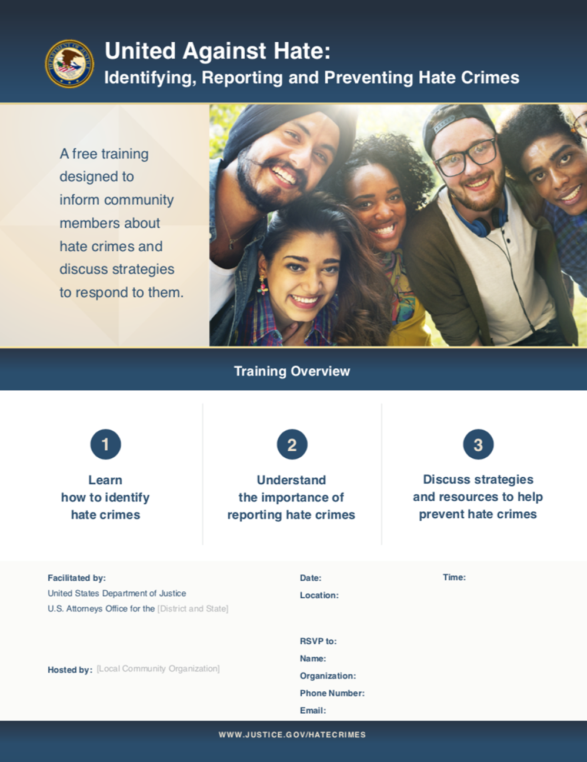Engage with federal and local officials to **combat hate crimes and discrimination**

*Federal and local officials working with community members to discuss effective strategies to prevent and respond to hate crimes and incidents.*

Insert Text here. Can edit font, size, color, and format.



**WEST WARWICK PUBLIC LIBRARY**

**1043 MAIN STREET**

**WEST WARWICK, R.I.**

**WEDNESDAY**

**AUGUST 30th, 2023**

**9:30 am to 11:30 am**

*Please register at* [*https://www.eventbrite.com/e/united-against-hate-tickets-686942171527?aff=oddtdtcreator*](https://www.eventbrite.com/e/united-against-hate-tickets-686942171527?aff=oddtdtcreator)

*Email: wfenner-aubin@tricountyri.org with any questions*

***To request interpreter services or reasonable accommodation, contact*** [***david.neill@usdoj.gov***](mailto:david.neill@usdoj.gov)

|  |  |  |
| --- | --- | --- |
| 1.  *Learn how to identify*  *hate crimes and incidents* | 2.  *Understand the importance of reporting* | 3.  *Discuss strategies to*  *prevent acts of hate* |

Program Overview

**In partnership with the Tri-County Community Action Program**